Ex 2: Setting Up a Zoho Creator Account and Exploring the Platform Architecture and Interface

1. Aim

To create a Zoho Creator account, build a sample application, and explore the platform architecture, user interface, forms, reports, and dashboards.

2. Setting Up Zoho Creator

Step 1: Create a Zoho Creator Account
- Open the Zoho Creator website.
- Sign up using an email address.
- Verify the email and log in.
- The Creator home page is displayed with the Applications dashboard.
Screenshot 1: Zoho Creator Home Page
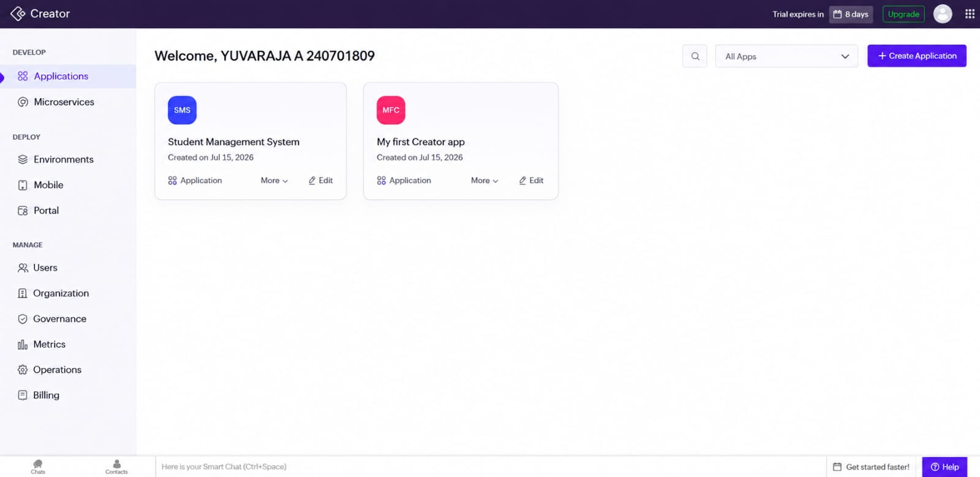

Step 2: Create a Sample Application
A sample application named Student Management System was created.
The application consists of:
- Student Details Form
- Student Details Report
The application stores information such as:
- Student Name
- Email
- Phone Number
- Address
- Register Number
Screenshot 2: Create New Application
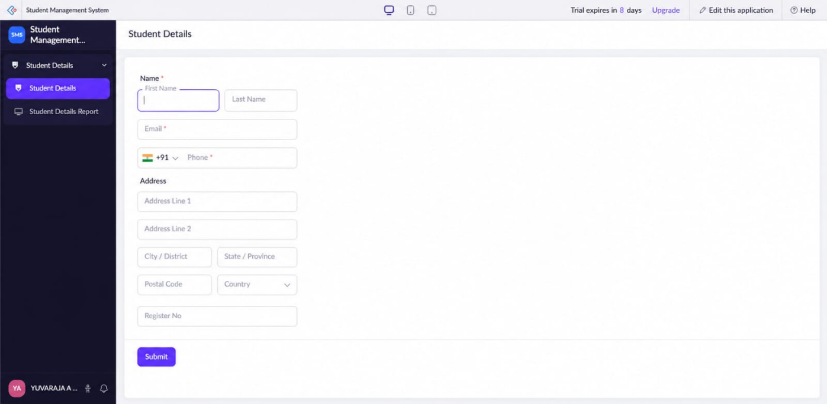

i) Sample Application Created
Application Name
Student Management System
Modules
- Student Details (Form)
- Student Details Report (Report)

ii) Screenshots
A. Form Screenshot
The Student Details form is used to enter student information into the application.

B. Report Screenshot
The report displays all student records in a tabular format.
The report includes:
- Name
- Email
- Phone
- Address
- Register Number
Screenshot
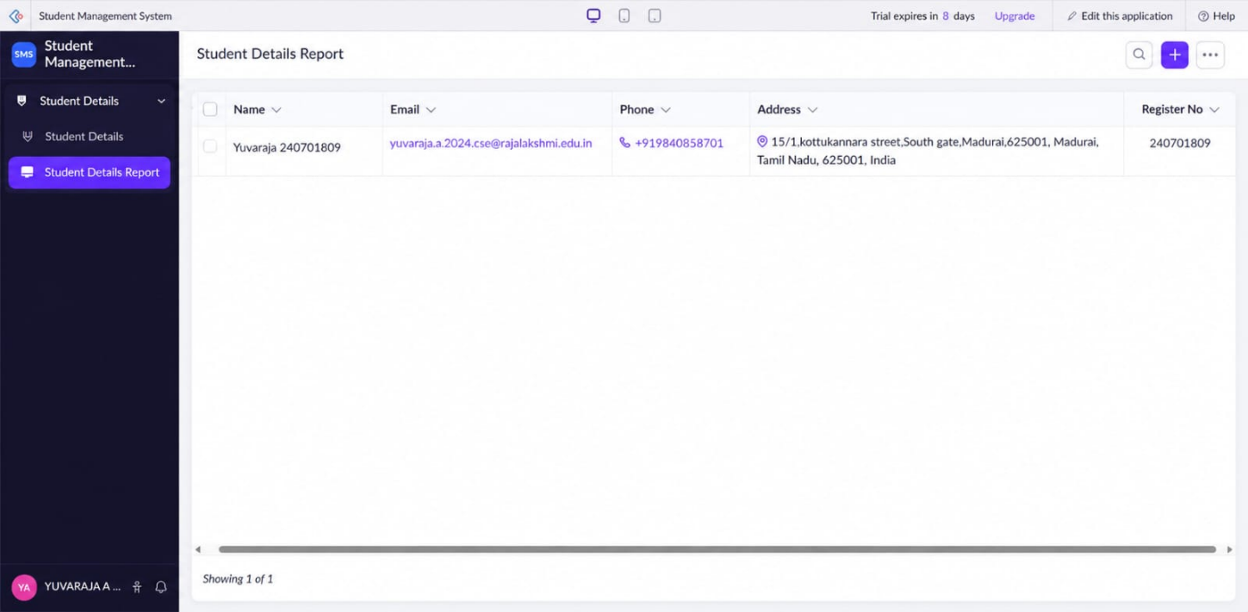

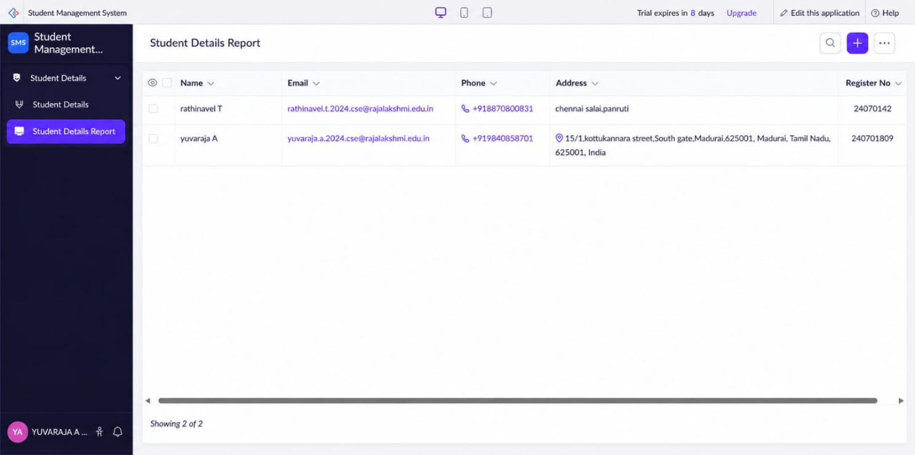

C. Dashboard
The application dashboard/home page displays all created applications and provides options to edit or create new applications.
Screenshot
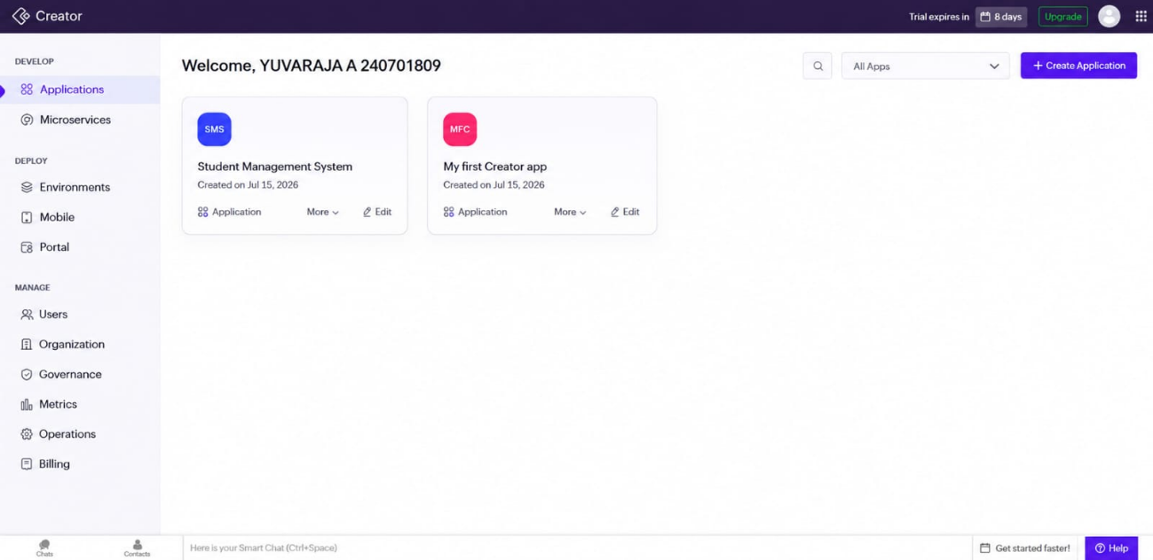

3. Exploring the Architecture and Interface
Interface Overview
The Zoho Creator platform provides a user-friendly interface that allows developers and administrators to create, deploy, and manage business applications from a centralized dashboard. The left navigation panel organizes features into three main sections: Develop, Deploy, and Manage.
Interface Components
The interface shown includes the following components:
Develop
- Applications
Create, view, and manage all business applications within the workspace.
- Microservices
Build and manage reusable services that can be integrated with applications for enhanced functionality.

Deploy
- Environments
Manage different environments such as Development, Testing, and Production for application deployment.
- Mobile
Configure and preview mobile versions of applications for Android and iOS devices.
- Portal
Create and manage customer or employee portals to provide external users with secure access to applications.
Manage
- Users
Add users, assign roles, and control application access permissions.
- Organization
Configure organization settings, account details, and workspace preferences.
- Governance
Monitor policies, compliance, and security settings for applications.
- Metrics
View application performance statistics, usage reports, and analytics.
- Operations
Monitor application operations, system activities, and administrative tasks.
- Billing
Manage subscription plans, invoices, and payment information.
Key Features of the Interface
- Navigation Menu: Provides quick access to application development, deployment, and management tools.
- Organized Categories: Features are grouped under Develop, Deploy, and Manage for easy navigation.
- Application Management: Enables users to create and maintain multiple applications from one dashboard.
- Administrative Tools: Offers centralized management of users, governance, operations, and billing.
- Deployment Options: Supports application deployment across different environments and mobile platforms.
The interface is designed to simplify application development and administration by providing an organized and intuitive navigation structure, enabling users to efficiently build, deploy, and manage low-code applications.

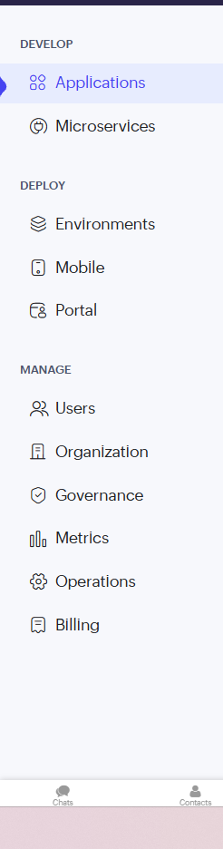

Result
Successfully created a Zoho Creator account, developed a sample Student Management System application, explored forms, reports, dashboard, and understood the basic architecture and interface of the Zoho Creator platform.

